

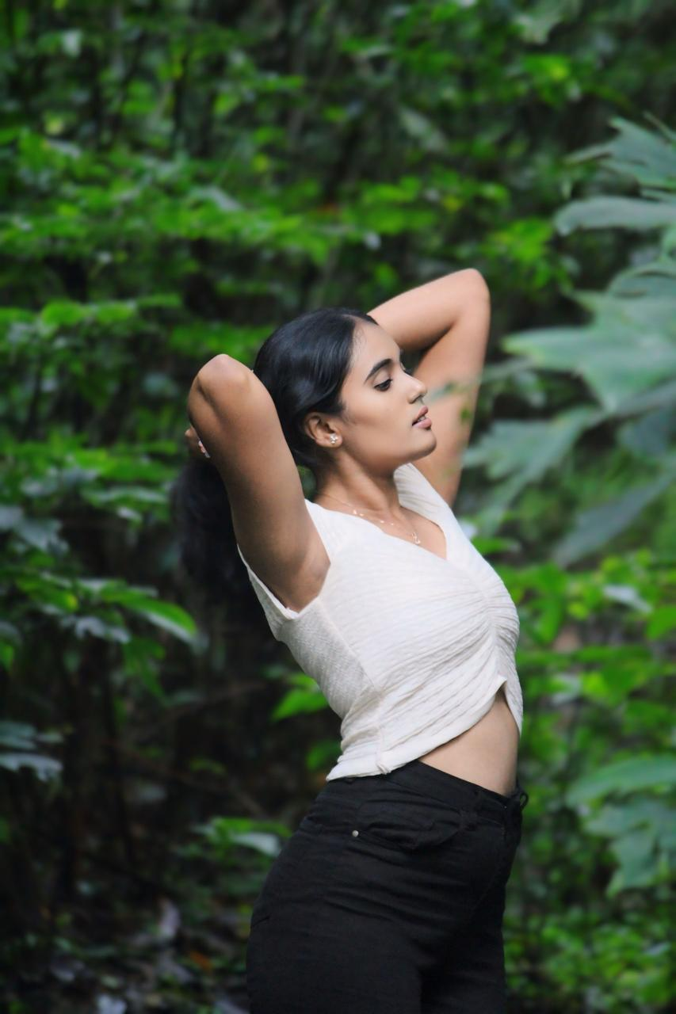fix your photo

|  |  |  |
| --- | --- | --- |
| **Name** | **:** | Sinchana B S |
| **Phone Number** | **:** | 9353428227 |
| **Email-Id** | **:** | Sinchanagowdabs93@gmail.com |
| **LinkedIn Profile** | **:** |  |
| **GitHub URL** | **:** |  |

# CAREER OBJECTIVE

# EDUCATION

|  |  |  |  |
| --- | --- | --- | --- |
| **Course Studied** | **Name of the Institution / University** | **Percentage/ CGPA** | **Year of Completion** |
| **B.E.** | Malnad college of engineering |  |  |
| **Computer Science and Engineering** |
| **12th** | Masters pu college | 87 | 2022 |
| **10th** | Srs prajan vidya school | 87.5 | 2020 |

**CERTIFICATION**

|  |  |  |
| --- | --- | --- |
| **Course Title** | **Certifier** | **Year** |
|  |  |  |
|  |  |  |
|  |  |  |
|  |  |  |
|  |  |  |
|  |  |  |

# INTERNSHIP

|  |  |  |
| --- | --- | --- |
| **Company Name** | **Duration** | **Details** |
|  |  |  |

**PROJECTS**

|  |  |  |
| --- | --- | --- |
| **Title** | **Year** | **Details** |
|  |  |  |
|  |  |  |
|  |  |  |

# TECHNICAL SKILL PROFICIENCY

|  |  |
| --- | --- |
| **Operating Systems** |  |
| **Programming Languages** | Python,c,java |
| **Application Packages** |  |
| **Others (Tools)** |  |

**ACADEMIC ACHIEVEMENTS**

# VOLUNTARY ACTIVITIES

# EXTRA CURRICULAR ACTIVITIES

# PERSONAL DETAILS

|  |  |  |
| --- | --- | --- |
| **Date of Birth & Age** | **:** | 06-12-2003 |
| **Gender** | **:** | female |
| **Father’s Name** | **:** | B.T Sathish |
| **Permanent Address** | **:** | Bittagowdanahalli hanuman arch opp |
| **Languages Known** | **:** | Kannada,English,hindi |
| **Date of Joining** | **:** |  |

**Date:**

**Signature: Place: Hassan**